**Practical No. 15 Write a program to demonstrate the use of URL and URLConnection class and its methods.**

**Exercise:**

1. **Write a program using URL class to retrieve the host, protocol, port and file of URL** [**http://www.msbte.org.in**](http://www.msbte.org.in)

import java.net.*;

class pract15_ex1

{

public static void main(String args[]) throws MalformedURLException

{ URL u1 = new URL("https://www.msbte.org.in");

System.out.println("Protocol: "+ u1.getProtocol());

System.out.println("Port: "+ u1.getPort());

System.out.println("Host: "+ u1.getHost());

System.out.println("File: "+ u1.getFile());

} }

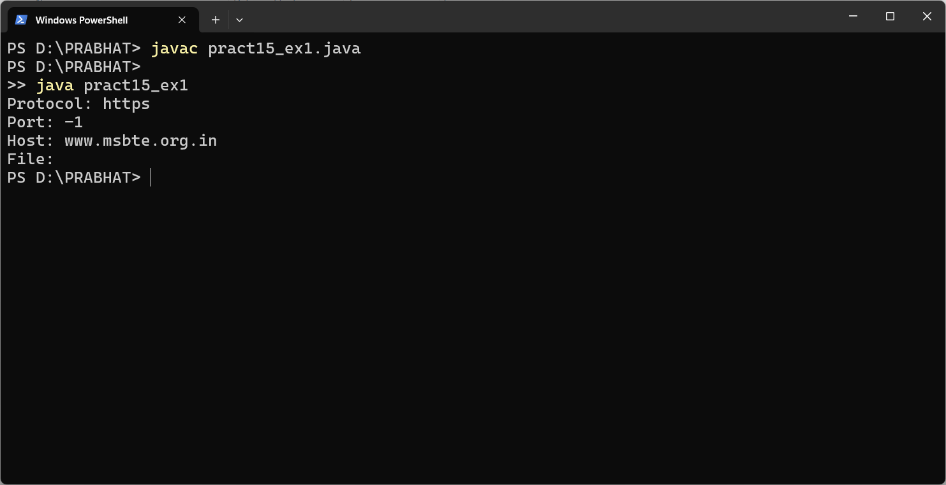

1. **Write a program using URL and URLConnection class to retrieve the date, content type, content length information of any entered URL.**

import java.net.*;

import java.util.*;

public class pract15_ex2

{

public static void main (String[] args) throws Exception

{

Scanner sc = new Scanner(System.in);

System.out.println("Enter URL : ");

String s = sc.nextLine();

URL hp = new URL (s);

URLConnection hpcon = hp.openConnection();

long d = hpcon.getDate();

if (d == 0)

{

System.out.println("No Date Available");}

else

{

System.out.println("Date : "+ new Date(d));

System.out.println("Content-type: "+ hpcon.getContentType());

d = hpcon.getExpiration();}

if (d == 0)

{

System.out.println("No Expiration Date Available");}

else{

System.out.println("Date Expiration : "+ new Date(d));

d = hpcon.getLastModified();}

if (d == 0){

System.out.println("No Modified Date Available");}

else

{

System.out.println("Date Modified : "+ new Date(d));}

int len = hpcon.getContentLength();

if (d == -1)

{

System.out.println("No Content Found");}

else{

System.out.println("Content Length : "+ len);}

}

}

**Output:**

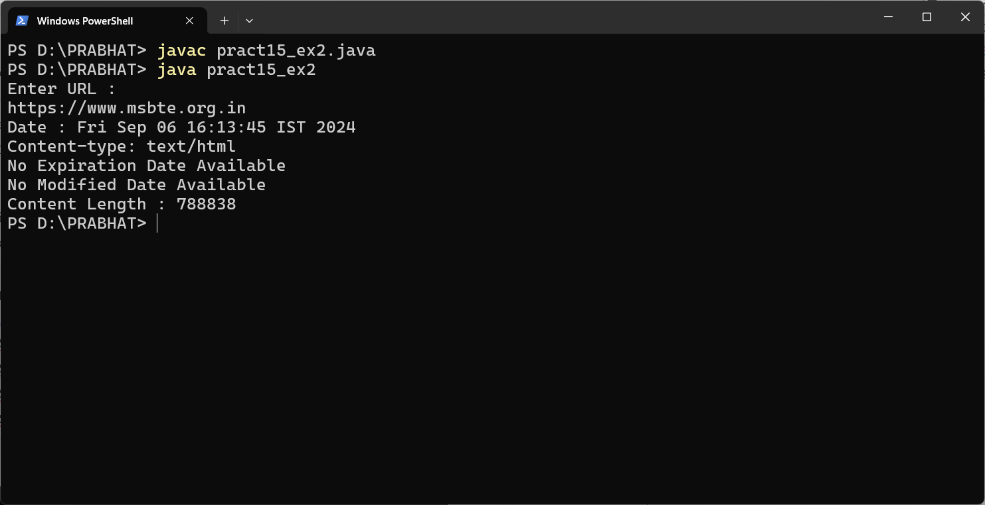

**X. Program Code:**

**1. Execute the following code and write the output.**

import java.net.*;

class pract15_X

{

public static void main(String args[]) throws MalformedURLException

{

URL hp = new URL("https://www.javatpoint.com/javafx-tutorial");

System.out.println("Protocol: " + hp.getProtocol());

System.out.println("Port: " + hp.getPort());

System.out.println("Host: " + hp.getHost());

System.out.println("File: " + hp.getFile());

System.out.println("Ext:" + hp.toExternalForm());

}

}

